CREATE DATABASE HospitalDB;

USE HospitalDB;

CREATE TABLE Patient (
PatientID INT PRIMARY KEY,
Age INT CHECK (Age > 0),
Gender CHAR(1),
AdmissionDate DATE NOT NULL
);

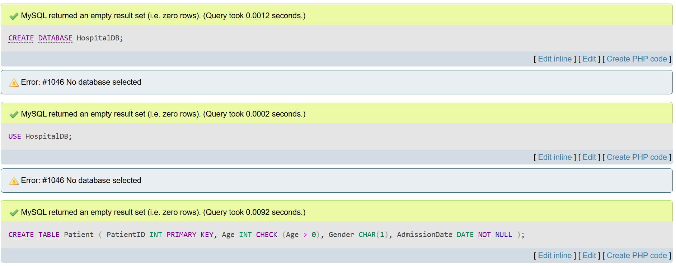

Select * from regions,jobs
Select * from regions CROSS JOIN jobs;

